

Recipes Recommender System

***Students:-***

***Amal Musleh 11717015***

***Mais Nana 11820902***

***Hala zraiq 11820488***

***Supervisor: Dr. Mai AbuSair***

*A project report submitted in partial fulfillment of the requirements for*

*B.Sc. degree in Computer Science.*

**Acknowledgements**

It has been a great opportunity to get a lot of experience in real-time projects, followed by the knowledge of how to design and analyze real projects. For that, we want to thank all the people who made it possible for students like us. Special thanks to the Graduation Projects Committee for the efforts they did to provide us with all useful information and making the path clear for us to implement all the education periods in real-time project design and analysis. Furthermore, we thank all the professors and lecturers for the interesting lectures they presented which had great benefits for all of us. We would like to express our deepest gratitude to our graduation project supervisor **“Dr.** ***Mai Abu Sair*”** for her patience and guidance throughout the semester. In addition, we have to thank and express our sincere appreciation to our families for their support and encouragement to reach this point. Moreover, we thank all the discussion committee members for their generous discussions and encouragement.

**Abstract**

Recommendation systems are tools for interacting with large and complex information spaces, they provide a personalized view of these spaces, giving priority to the elements that are likely to be of interest to the user.

Most of the big players in the industry like Google, Amazon, EBay, etc. use some sort of recommendation system in the background to recommend personalized products, ads, and videos.

Recommendation systems play an important role in helping people find recipes that interest them and match their eating habits, and recommendation systems make use of user profiles, user browsing history, search history, and filtering technologies to gather information and help users find the right information from a large volume of data.

**Table of Contents**

[Abstract](https://docs.google.com/document/d/1aOQ8L4JmXKr4YasebYjd7ENNoHUbQ7L9/edit#bookmark=id.30j0zll) [2](https://docs.google.com/document/d/1aOQ8L4JmXKr4YasebYjd7ENNoHUbQ7L9/edit#bookmark=id.30j0zll)

[Acknowledgement](https://docs.google.com/document/d/1aOQ8L4JmXKr4YasebYjd7ENNoHUbQ7L9/edit#bookmark=id.1fob9te) [3](https://docs.google.com/document/d/1aOQ8L4JmXKr4YasebYjd7ENNoHUbQ7L9/edit#bookmark=id.1fob9te)

Table of Contents 4

List of Figures 5

[1.1 Introduction](https://docs.google.com/document/d/1aOQ8L4JmXKr4YasebYjd7ENNoHUbQ7L9/edit#bookmark=id.tyjcwt) [6](https://docs.google.com/document/d/1aOQ8L4JmXKr4YasebYjd7ENNoHUbQ7L9/edit#bookmark=id.tyjcwt)

[1.**2** Problem Statement](https://docs.google.com/document/d/1aOQ8L4JmXKr4YasebYjd7ENNoHUbQ7L9/edit#bookmark=id.tyjcwt) [7](https://docs.google.com/document/d/1aOQ8L4JmXKr4YasebYjd7ENNoHUbQ7L9/edit#bookmark=id.tyjcwt)

[1.3 Proposed System](https://docs.google.com/document/d/1aOQ8L4JmXKr4YasebYjd7ENNoHUbQ7L9/edit#bookmark=id.3dy6vkm) [8](https://docs.google.com/document/d/1aOQ8L4JmXKr4YasebYjd7ENNoHUbQ7L9/edit#bookmark=id.3dy6vkm)

[1.4 Project Scope](https://docs.google.com/document/d/1aOQ8L4JmXKr4YasebYjd7ENNoHUbQ7L9/edit#bookmark=id.1t3h5sf) [8](https://docs.google.com/document/d/1aOQ8L4JmXKr4YasebYjd7ENNoHUbQ7L9/edit#bookmark=id.1t3h5sf)

[1.5 Goals and Objectives](https://docs.google.com/document/d/1aOQ8L4JmXKr4YasebYjd7ENNoHUbQ7L9/edit#bookmark=id.1t3h5sf) [9](https://docs.google.com/document/d/1aOQ8L4JmXKr4YasebYjd7ENNoHUbQ7L9/edit#bookmark=id.1t3h5sf)

[2.1 Introduction](https://docs.google.com/document/d/1aOQ8L4JmXKr4YasebYjd7ENNoHUbQ7L9/edit#bookmark=id.3as4poj) [10](https://docs.google.com/document/d/1aOQ8L4JmXKr4YasebYjd7ENNoHUbQ7L9/edit#bookmark=id.3as4poj)

[2.2 Current System](https://docs.google.com/document/d/1aOQ8L4JmXKr4YasebYjd7ENNoHUbQ7L9/edit#bookmark=id.3as4poj) [10](https://docs.google.com/document/d/1aOQ8L4JmXKr4YasebYjd7ENNoHUbQ7L9/edit#bookmark=id.3as4poj)

[2.3 Feasibility Study](https://docs.google.com/document/d/1aOQ8L4JmXKr4YasebYjd7ENNoHUbQ7L9/edit#bookmark=id.2s8eyo1) [11](https://docs.google.com/document/d/1aOQ8L4JmXKr4YasebYjd7ENNoHUbQ7L9/edit#bookmark=id.2s8eyo1)

[2.4 Methodology (Content-Based Filtering)](https://docs.google.com/document/d/1aOQ8L4JmXKr4YasebYjd7ENNoHUbQ7L9/edit#bookmark=id.26in1rg) [14](https://docs.google.com/document/d/1aOQ8L4JmXKr4YasebYjd7ENNoHUbQ7L9/edit#bookmark=id.26in1rg)

[3.1 Product perspective](https://docs.google.com/document/d/1aOQ8L4JmXKr4YasebYjd7ENNoHUbQ7L9/edit#bookmark=id.lnxbz9) [15](https://docs.google.com/document/d/1aOQ8L4JmXKr4YasebYjd7ENNoHUbQ7L9/edit#bookmark=id.lnxbz9)

[3.2 System Environment](https://docs.google.com/document/d/1aOQ8L4JmXKr4YasebYjd7ENNoHUbQ7L9/edit#bookmark=id.lnxbz9) [15](https://docs.google.com/document/d/1aOQ8L4JmXKr4YasebYjd7ENNoHUbQ7L9/edit#bookmark=id.lnxbz9)

[3.3 Functional Requirements Specification](https://docs.google.com/document/d/1aOQ8L4JmXKr4YasebYjd7ENNoHUbQ7L9/edit#bookmark=id.35nkun2) [16](https://docs.google.com/document/d/1aOQ8L4JmXKr4YasebYjd7ENNoHUbQ7L9/edit#bookmark=id.35nkun2)

[3.4 Non-Functional Requirements](https://docs.google.com/document/d/1aOQ8L4JmXKr4YasebYjd7ENNoHUbQ7L9/edit#bookmark=id.1ksv4uv) [17](https://docs.google.com/document/d/1aOQ8L4JmXKr4YasebYjd7ENNoHUbQ7L9/edit#bookmark=id.1ksv4uv)

[3.5 Detailed Functional Requirement](https://docs.google.com/document/d/1aOQ8L4JmXKr4YasebYjd7ENNoHUbQ7L9/edit#bookmark=id.1pxezwc) [18](https://docs.google.com/document/d/1aOQ8L4JmXKr4YasebYjd7ENNoHUbQ7L9/edit#bookmark=id.1pxezwc)

[3.6 Detailed Non-Functional Requirement](https://docs.google.com/document/d/1aOQ8L4JmXKr4YasebYjd7ENNoHUbQ7L9/edit#bookmark=id.1pxezwc) [19](https://docs.google.com/document/d/1aOQ8L4JmXKr4YasebYjd7ENNoHUbQ7L9/edit#bookmark=id.1pxezwc)

[3.7 Algorithm](https://docs.google.com/document/d/1aOQ8L4JmXKr4YasebYjd7ENNoHUbQ7L9/edit#bookmark=id.3as4poj) [20](https://docs.google.com/document/d/1aOQ8L4JmXKr4YasebYjd7ENNoHUbQ7L9/edit#bookmark=id.3as4poj)

[3.8 System design](https://docs.google.com/document/d/1aOQ8L4JmXKr4YasebYjd7ENNoHUbQ7L9/edit#bookmark=id.3as4poj)

[3.8.1 Use case diagram](https://docs.google.com/document/d/1aOQ8L4JmXKr4YasebYjd7ENNoHUbQ7L9/edit#bookmark=id.3as4poj) [25](https://docs.google.com/document/d/1aOQ8L4JmXKr4YasebYjd7ENNoHUbQ7L9/edit#bookmark=id.3as4poj)

[3.8.2 Sequence diagram](https://docs.google.com/document/d/1aOQ8L4JmXKr4YasebYjd7ENNoHUbQ7L9/edit#bookmark=id.3as4poj) 26

[3.8.](https://docs.google.com/document/d/1aOQ8L4JmXKr4YasebYjd7ENNoHUbQ7L9/edit#bookmark=id.3as4poj)3 Activity diagram 32

3.8.4 Entity relation diagram [3](https://docs.google.com/document/d/1aOQ8L4JmXKr4YasebYjd7ENNoHUbQ7L9/edit#bookmark=id.3as4poj)8

[3.8.5 Class diagram](https://docs.google.com/document/d/1aOQ8L4JmXKr4YasebYjd7ENNoHUbQ7L9/edit#bookmark=id.3as4poj) [3](https://docs.google.com/document/d/1aOQ8L4JmXKr4YasebYjd7ENNoHUbQ7L9/edit#bookmark=id.3as4poj)9

[4.1 Software architecture](https://docs.google.com/document/d/1aOQ8L4JmXKr4YasebYjd7ENNoHUbQ7L9/edit#bookmark=id.2s8eyo1) 40

[4.2 Hardware architecture](https://docs.google.com/document/d/1aOQ8L4JmXKr4YasebYjd7ENNoHUbQ7L9/edit#bookmark=id.26in1rg) 41

[5.1 Conclusion](https://docs.google.com/document/d/1aOQ8L4JmXKr4YasebYjd7ENNoHUbQ7L9/edit#bookmark=id.lnxbz9) 42

[5.2 Future work](https://docs.google.com/document/d/1aOQ8L4JmXKr4YasebYjd7ENNoHUbQ7L9/edit#bookmark=id.lnxbz9) 43

List of Figures

Figure 1: Methodology ……….……………………………………………………...…14

Figure 2: System environment ……….……………………………………………...…15

Figure 3: Use Case Diagram ……….………………………………………...............…25

Figure 4: Sequence Diagrams (login) ……….…………….………………...........…….26

Figure 5: Sequence Diagrams (open appointment) ……...……………………...........…27

Figure 6: Sequence Diagram (mother) ……….…………………...……….................…28

Figure 7: Sequence Diagram (center Administrator) ……….……….……….............…29

Figure 8: Entity Relation Diagram ……….……………………………..…....................30

Figure 9: Class Diagram ……….………………………….……………...................…31

**1.1 Introduction**

**1.2 Problem Statement**

Because there are many sites around the world that collect many different recipes, for example, Food.com1, which is one of the largest recipe sharing sites in the world with more than half a million recipes, searching for a recipe within this huge amount of data online to get a recipe Satisfying is very difficult, especially when recipes are linked to heterogeneous content such as ingredients, instructions, nutrients, and user feedback, for this reason especially recipe recommendation systems have been created that have the ability to help users navigate through a lot of online recipe data and recommend recipes that match users' preferences and tastes.

**1.3 Proposed System**

The main purpose of the recommendation system is to give recommendations that suit the user’s taste based on the user’s interaction with other recipes and to facilitate the process of searching for recipes, whether by name or ingredients, which guarantees the user to get the best results from the search process

**1.4 Project Scope**

The system is a mobile application that works on Android and iOS built using the filter and is used by all ages easily.

To build this application, the content-based systems algorithm was used, which will be recommended later

**1.5 Goals and Objectives**

* Find recipes similar to the user's taste.
* Facilitate the process of preparing and finding meals for users
* Give a satisfactory outcome from the research process

.

**CHAPTER TWO**

**LITERATURE AND METHODOLOGY**

**2.1 Introduction**

Each system has its own functions, "Recipe Recommendation System" which was introduced to provide new functionality for food applications. After reading this section, customers will be able to discern the differences between the existing systems and our new system. Moreover, they will have the ability to know the pros and cons of each system, so that customers can easily choose the best option with a complete understanding of each system.

**2.2 Current System**

After the research, we found that there is no special application for recipes that helps in publishing special food recipes in Palestine and searching for recipes according to the name of the ingredient and the name, as the currently used method is to publish recipes through social media, which some find an old and difficult way to find the desired in addition to the existing applications Currently does not support the publication of a person's recipes.

**2.3 Feasibility Study**

**Project Description**

Recipe Recommendation System is an Android application used by mothers and people who are interested in learning and trying new recipes and publishing their own recipes

* **Android:**

Upon the first use of the application, the user must create an account if he is not registered before, as he enters the required information on the account creation page.

Others contain some questions related to whether he suffers from certain diseases and others to determine the necessary nutrients.

The application also contains a personal user account through which he can add his own recipe and display it with the rest of the recipes within the application, in addition to the recipes page that displays the general and suggested recipes for the user, and there is also a search page through which he can search for any recipe he wants, whether by name or according to a specific component.

* **Preliminary feasibility study**

The system is a mobile application that helps to save time and effort in obtaining satisfactory results when searching for a specific recipe. As for the type of market, it is a very non-competitive market, since there are competitors who have an “almost” similar system of offering and suggesting recipes that suit the user. Thus, the process of designing such a system is not difficult, because the enabling elements are available almost completely, which saves time and effort in design processing.

ال

* **Market Feasibility Study**

With the development of technology and the increasing demand for software products .

The system will be very successful in many areas of life, particularly in the food sector. There are many websites that provide food recipes online, but the need for a system that makes it easier for users to find their recipes easily and smoothly prompted us to think about and develop this system, a system that studies the user’s behavior to be able to give him the best output that suits his needs.

* **Technical Study of the Project**

The recipe recommendation system needs to produce several supplies, which consist of Android programmers to produce this mobile application, market analysts, Android and iOS devices, and funds to produce this application.

**2.4 Methodology**

**2.4.1Dataset:**

After studying the system and its requirements, we tried to find the appropriate data to match the system we want to configure, so we relied on the data found in kaggl site, which contains 231 thousand recipes,Since this dataset does not contain recipes images

We created a new column for the images in the dataset and then we clean it .

The dataset can be used to answer a lot of questions

related to Food Recipes such as time required to prepare a dish, most common ingredients, steps ,nutrition.

**2.4.2 Recommendation System**

This app used content-based filtering which enabled us to recommend recipes to people based on the attributes i.e. ingredients.

To measure the similarity between the ingredients provided by user and ingredients of a recipe we have used Cosine Similarity.

Cosine Similarity is a metric that is used to measure how similar two items are and generate a scores based on the similarity By using the cosine similarity function we get the the scores of the matching recipes and then that scores are passed to getRecommendation function to

rank these scores and output a pandas containing all the details of top N recommendations.

We have created an API for our model using Python

framework Flask .

**2.4.3 Pre-processing Ingredients**

In this step we have given each unique ingredient a unique ID in order to build a matrix term frequency for recipes

**CHAPTER THREE**

**SYSTEM ANALYSIS AND DESIGN**

**3.1 Product Perspective**

Recipe Recommandation is a flutter-based program. It will be designed to make it easy for users to search and find recipes and help them share their experiences in making delicious recipes. The system must be developed to be compatible with Android and ios operating systems. The front end of the system will be developed using FLUTTER, and the backend will be developed using PHP ,JSON,FLASK and Python.

**3.2 How The System Works**

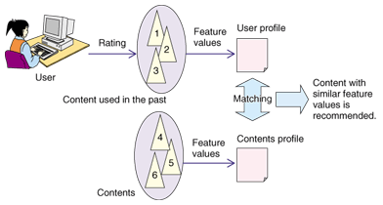

**Figure 2 -How The System Work**

**3.3 Functional Requirements Specification**

This section describes the use cases for both the system and the user separately. These are the use cases that management will provide for the recipe recommendation system:

**3.3.1 For the user:**

* Log in to the system
* Discover recipes and benefit from them
* Search for recipes
* Add your own recipe
* Find recipes to suit your taste

**3.4 Non-Functional Requirements**

Portability: The app only works on Android devices

Ease of use: The design of our app is usable. As our interface is easy to use, it is easy to understand and use by everyone.

Efficiency: The system is able to absorb all the inputs to give the results to the fullest, quickly and easily.

Safe and reliable: the system maintains the privacy of users and

It achieves high security to save their data

Availability: The system will be available to the users through the Application.

Performance:

* Speed in performance.
* Accuracy in performance.
* Accuracy in the search.
* Ease of use.
* Providing additional confidence to the clients of the office.
* Quickly retrieve information.

**3.5 Detailed Functional Requirement**

**USER** :

The user who owns an account of the application is the only one who can interact with the system, where he can perform some operations such as adding, searching and rating recipes.

**3.6 Detailed Non-functional Requirements**

* The system saves time and effort for users who search for a specific food through applications that collect millions of recipes.
* The system allows users to navigate through a lot of recipe data online and recommend recipes that match users' preferences.
* The system must allow users to access information anywhere and at any time in the presence of the Internet.

**3.7 System Design**

**3.7.1 Use Case Diagram**

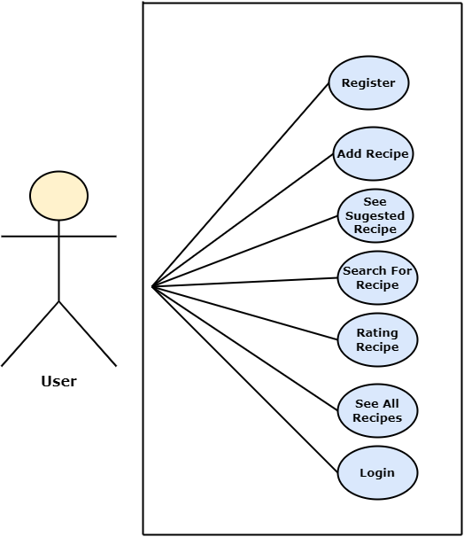

**Figure 3 - Use Case Diagram**

**3.7.2 Sequence Diagrams:**

**3.7.2.1 Register:**

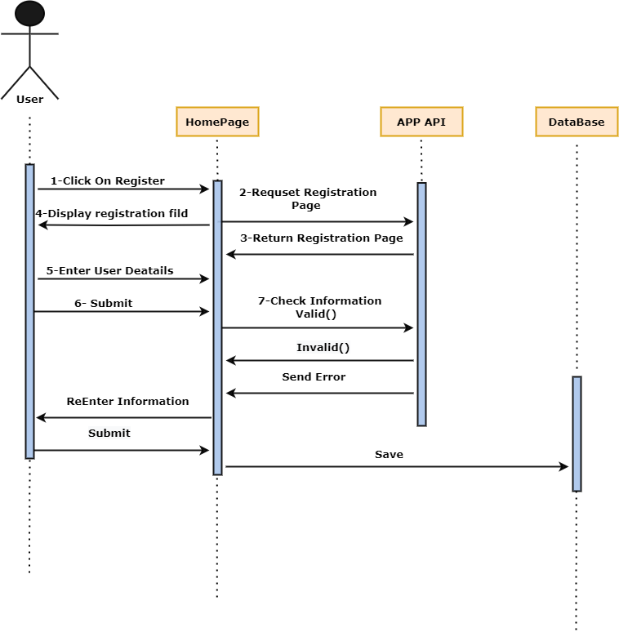

**Figure 4 - Sequence Diagram (Register)**

**3.7.2.2 login:**

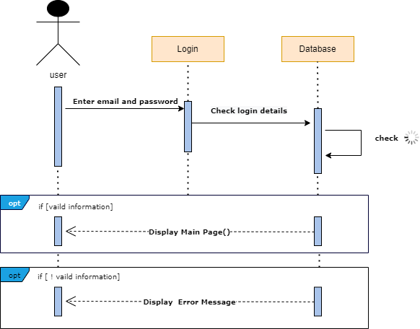

**Figure 5 - Sequence Diagram (login)**

**3.7.2.3 View Recipe:**

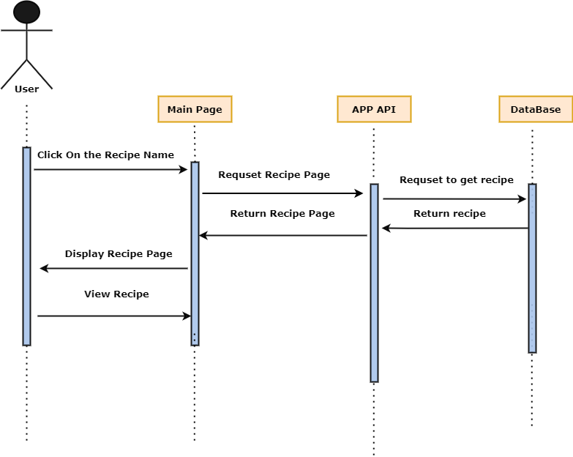

**Figure 6- Sequence Diagram (View Recipe)**

**3.7.2.4 search Recipe:**

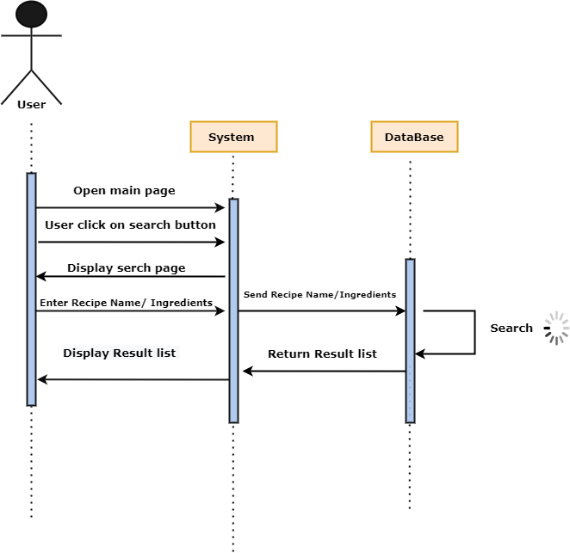

**Figure 7- Sequence Diagram (Search Recipe)**

**3.7.2.5 Rating Recipe:**

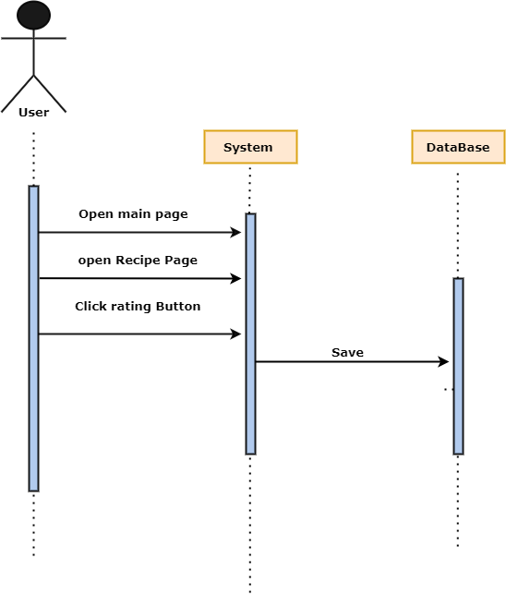

**Figure 8- Sequence Diagram (Rating Recipe)**

[**3.7.**](https://docs.google.com/document/d/1aOQ8L4JmXKr4YasebYjd7ENNoHUbQ7L9/edit#bookmark=id.3as4poj)**3 Activity Diagram**

**3.7.3.1 Login :**

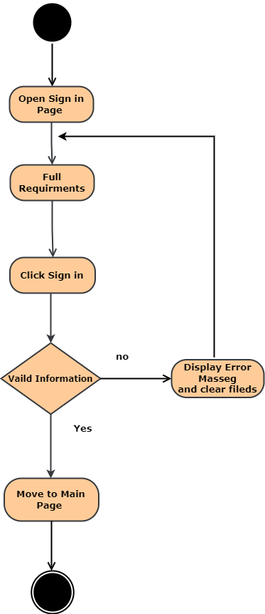

**Figure 9- Activity Diagram (Login)**

**3.7.3.2 Registration :**

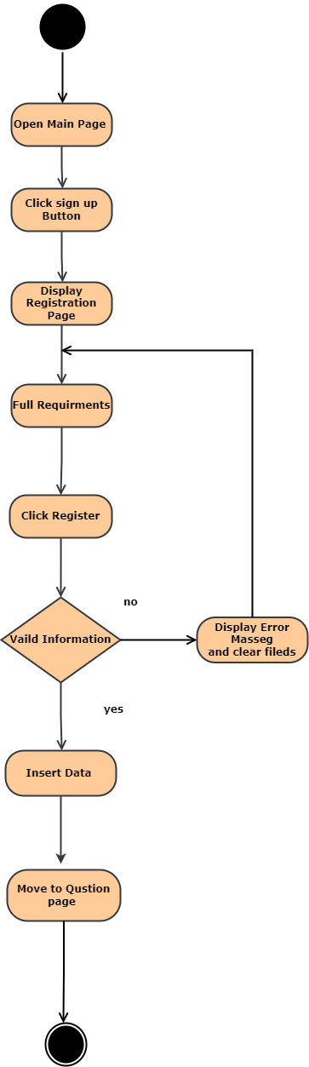

**Figure 10- Activity Diagram (Registration)**

**3.7.3.3 Search Recipe :**

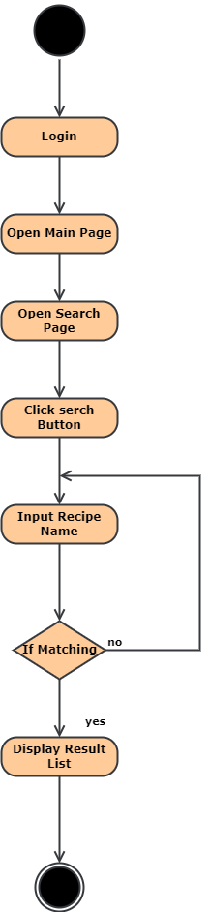

**Figure 11- Activity Diagram (Search Recipe)**

**3.7.3.4 View Recipe :**

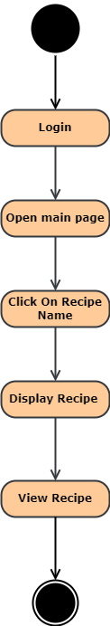

**Figure 12- Activity Diagram (View Recipe)**

**3.7.3.5 Rating Recipe :**

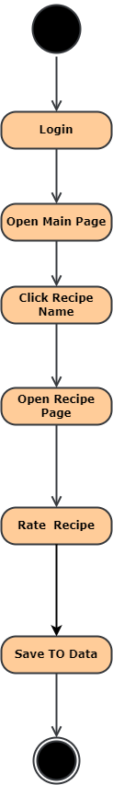

**Figure 13- Activity Diagram (Rate A Recipe)**

**3.7.4 Entity relation diagram**

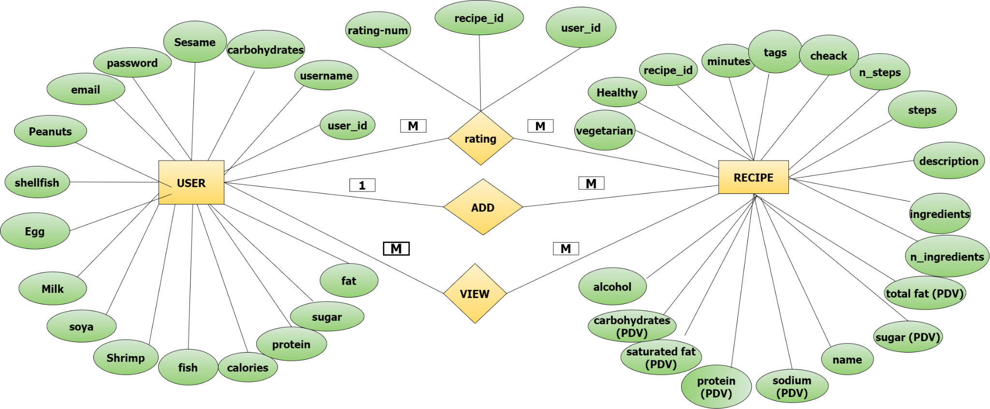

[**3.7.5 Class diagram**](https://docs.google.com/document/d/1aOQ8L4JmXKr4YasebYjd7ENNoHUbQ7L9/edit#bookmark=id.3as4poj)

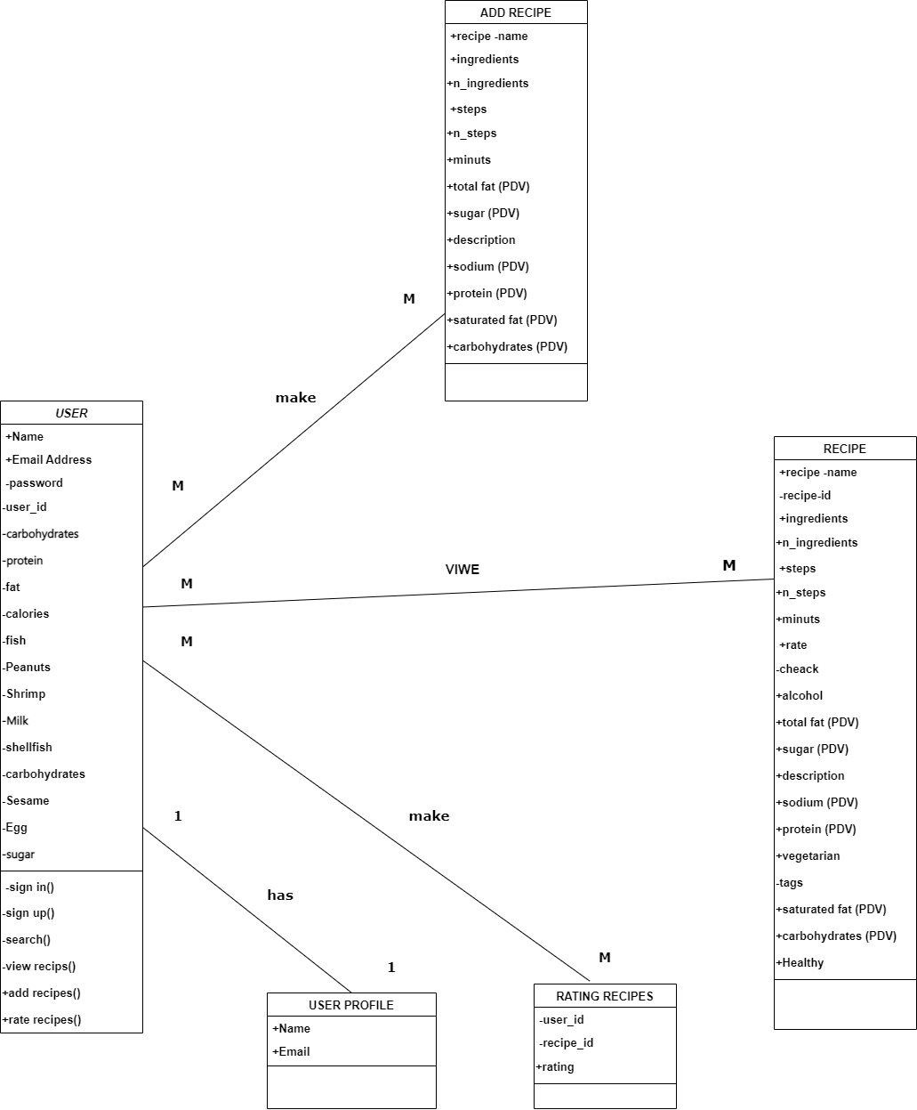

**CHAPTER FOUR**

**System Architecture**

**4.1 Software Architecture**

The final application for the main user will consist of an application that will allow people to interact with the system, by creating an account or logging in to the system, so that the person can take advantage of the features provided by the application, as the application will depend on internet access.

The application will consist of the main user interface that displays the main information of the application, and this interface will be non-interactive, and the next interface through which the user can enter the application by entering his personal email and password, and the main interface in the application which is used to display the recipes and recipes that he proposes There is another interface that contains the recipe steps and ingredients needed to prepare it, there is also a search interface through which one can search for recipes by the name or required ingredient, and an additional interface through which he adds his recipe and stores it to display it to other users who in turn open and evaluate this recipe . Behavior and offers suggestions for recipes to suit his taste which are displayed on the main interface.

**4.2 Hardware Architecture**

There are no complex hardware architectural needs. Since to work with a mobile app, everything is included in the API during development and with recent standardization and UI extensibility for apps and cross-device similarity performance, the app should work on all devices that can run the Android and iOS version it was designed for. The user will interact with the application through the phone's touch screen, and the interfaces will be displayed through the screen for the user to interact with and benefit from.

**CHAPTER FIVE**

**SYSTEM EVOLUTION**

**5.1 Conclusion**

In the end, we need such an application in our lives, which helps in addressing many central issues in human society, most of which are the inability of people to find food recipes that suit their tastes easily through recipes publishing sites, in addition to the difficulty of searching online.

Recipe sites, in particular, contain a large amount of food data because people are eager to share recipes created online. Our app provides an opportunity for other users to rate recipes and add their own, helping people form the habit of referring to these sites when deciding what to eat. With food sites collecting millions of recipes, searching through this vast amount of online recipe resources to find a satisfying recipe is always difficult, especially when recipes are associated with heterogeneous content such as ingredients, instructions, nutrients, and more.

Therefore, the recipe recommendation system has the ability to help users navigate through a lot of online recipe data and recommend recipes that match users' preferences and historical behavior, which helps users save time and effort in searching for good recipes and helps them get satisfactory results that fit their tastes.

**5.2 Future Work**

* We are considering using the image processing feature to make the app more flexible, so that anyone can search for a specific food using an image. Once the image is entered into the application and clicked on the search button, the results are shown to the user
* Add a chat system
* Giving recommendations to the user based on analysis of comments on recipes
* Create a list of purchases so that the user can add the missing items to this list for reference later

**THE END**